Exercise no:10

Date:21.11.20

Aim:

To write a python program print the number of upper case letters and lower case letters in a given string.

Program:

def string_test(s):

d={"upper_case":0,"lower_case":0}

for i in s:

if i.isupper():

d["upper_case"]+=1

elif i.islower():

d["lower_case"]+=1

else:

pass

print("No.of Upper case characters:",d["upper_case"])

print("No.of Lower case characters:",d["lower_case"])

s=input()

string_test(s)

Link:

<http://103.53.53.18/mod/vpl/forms/edit.php?id=325&userid=1702>

Output:

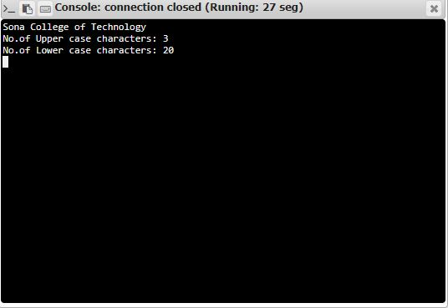

Result:

Thus the above program has been successfully executed and the output is verified.